Until activity: How to run copy activity in loop until order.csv file is arrived in adls and paste it

1. Create linked sevice
2. And dataset for source
3. Now create one variable flag

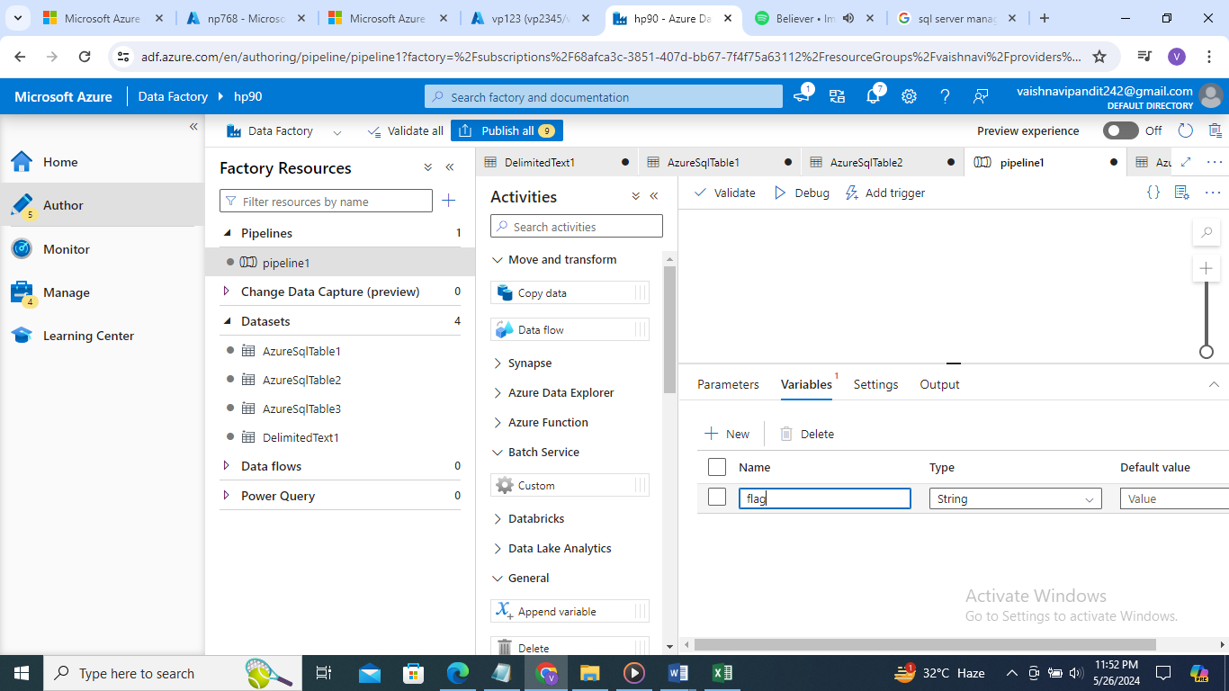

1. And set it to false

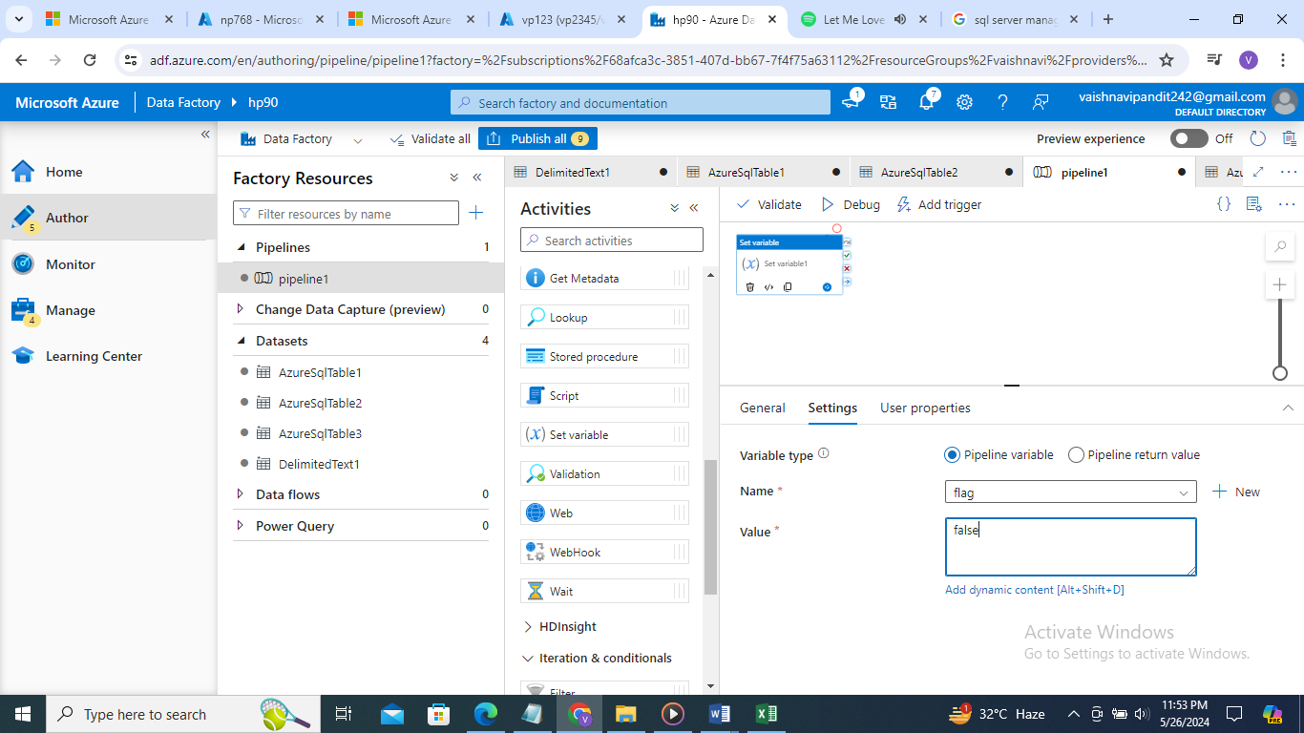

1. Now create until activity to check each folder

If false it will check folder

Now in until aactivity->setting->expression->functions->equals->flag variable->true

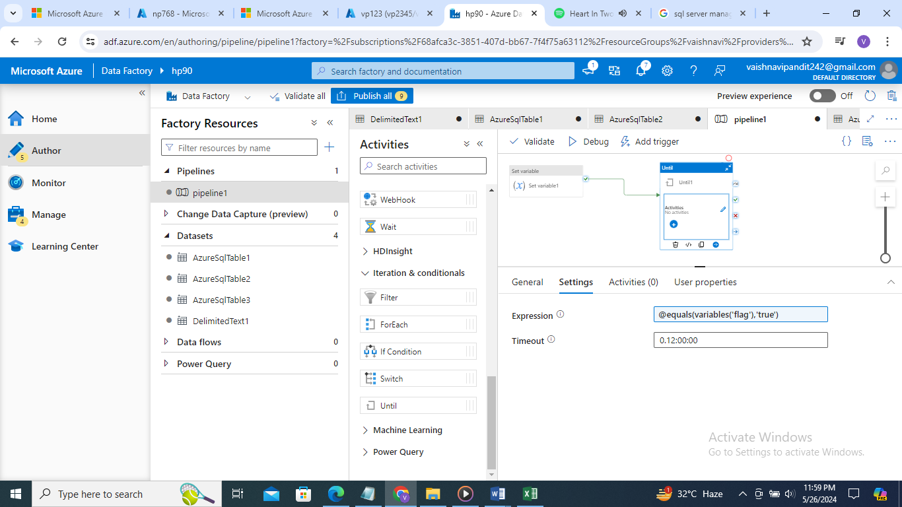

1. Now create get metadata activity in until

In settings add dataset and in field list exist

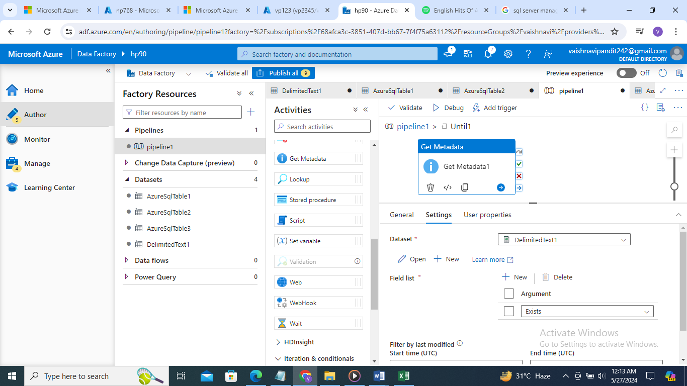

1. Now create if activity in if activity

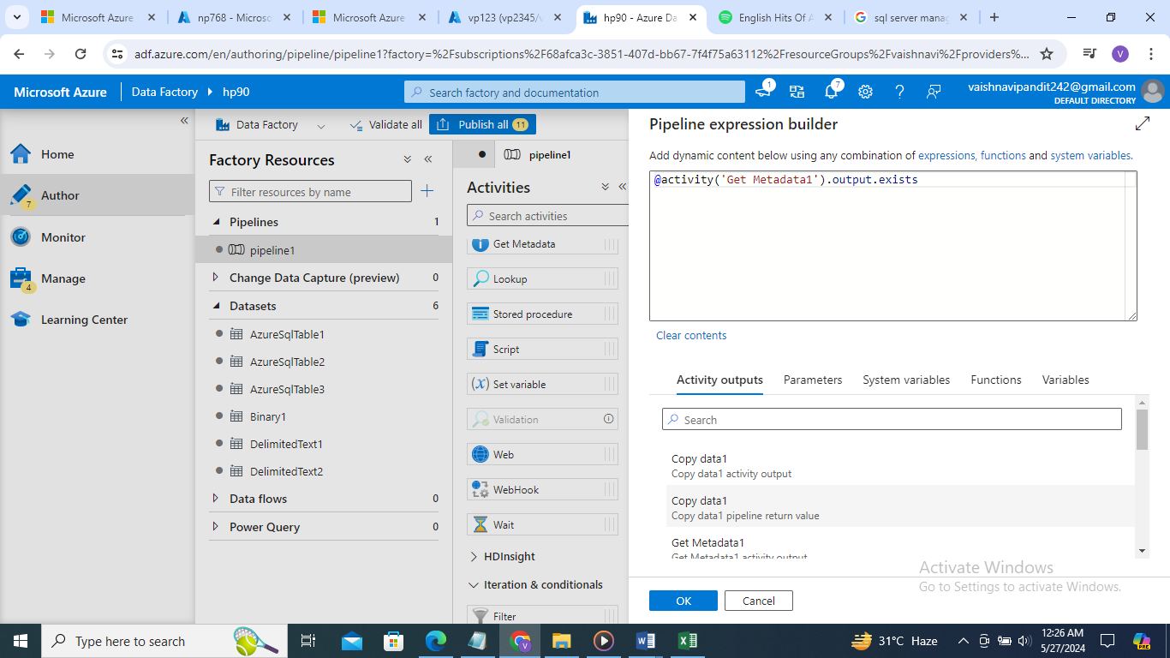

1. in true copy activity and set vriable activity to make flag true
2. And in false wait for 1sec